H.T.No:2303A51656
Batch 28
Task 1(Privacy and Data Security in AI-Generated Code):
Prompt:
Please generate a simple Python login system. The system should allow new users to register by providing a username and password, and existing users to log in with their credentials. For simplicity, store the user credentials (username and password) in-memory, perhaps using a dictionary. Avoid advanced features like database integration or complex password hashing for now. The system should provide clear feedback on successful registration/login or failed attempts."
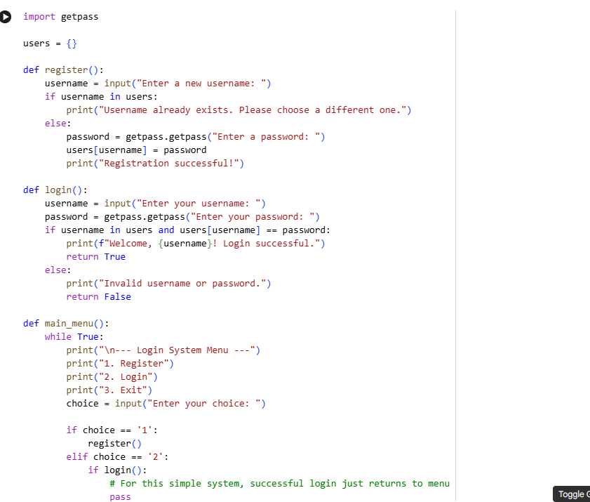
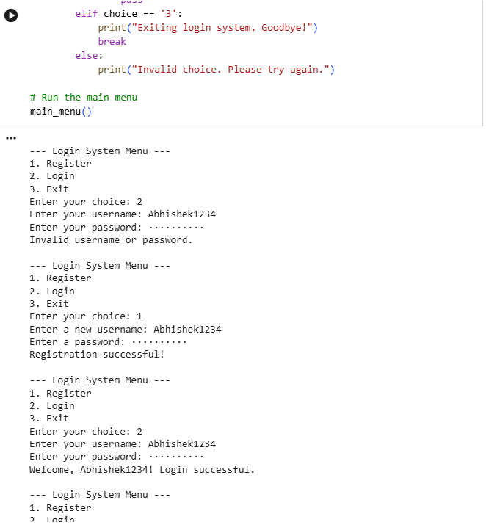
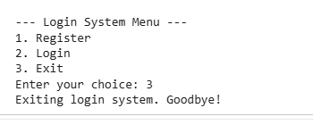
Identified Security Risks in Initial Code
Based on the analysis of the AI-generated Python login system, the following security risks have been identified:
1. Plain Text Password Storage
- Location: register() function, specifically the line users[username] = password.
- Description: The system stores user passwords directly in a dictionary (users) without any form of hashing or encryption. This means that if an attacker gains access to the users dictionary (e.g., through a compromise of the system's memory or a dump of the application state), they would immediately have access to all user passwords in plain, readable text. This is a critical security vulnerability as it allows for easy credential theft.
2. Plain Text Password Comparison
- Location: login() function, specifically the condition users[username] == password.
- Description: When a user attempts to log in, the system compares the plain text password provided by the user directly with the plain text password stored in the users dictionary. This practice is insecure because even if passwords were stored securely (e.g., hashed), comparing them in plain text would still require retrieving the plain text password, thereby exposing it during the authentication process. It also implies that if the stored password was compromised, authentication would still succeed with the compromised plain text password.
3. Lack of Input Validation
- Description: The system does not perform any validation on the length or complexity of the username or password during registration. Users can create very short, simple, or common passwords, making them highly susceptible to dictionary attacks or brute-force attempts. A strong password policy (minimum length, character types, etc.) is crucial for security.
4. No Brute-Force Protection
- Description: The system lacks any mechanisms to prevent brute-force attacks. An attacker can repeatedly attempt to log in with different username/password combinations without any restrictions (e.g., account lockout after multiple failed attempts, CAPTCHA, or rate limiting). This makes it easy for an attacker to systematically guess credentials until a correct one is found.
5. In-Memory Storage (Data Volatility)
- Description: While not strictly a security risk in terms of credential exposure, storing users in-memory means all user data is lost when the program terminates. This makes the system impractical for persistent use and could be considered an operational weakness.
- Revise Code for Security
- Subtask:
- Modify the identified insecure parts of the login system code to improve security. This includes implementing secure password handling (e.g., hashing), avoiding hardcoded credentials, and adding input validation.

- Reasoning: The first step in revising the code for security, as per the instructions, is to install the bcrypt library, which will be used for password hashing.

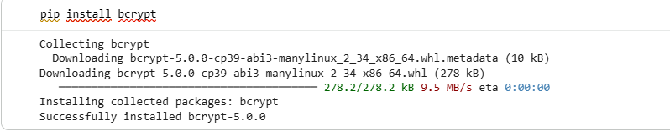
Reasoning: Now that bcrypt is installed, I will modify the register() and login() functions to implement secure password handling (hashing), add input validation for usernames and passwords, and incorporate the bcrypt library for secure comparison.
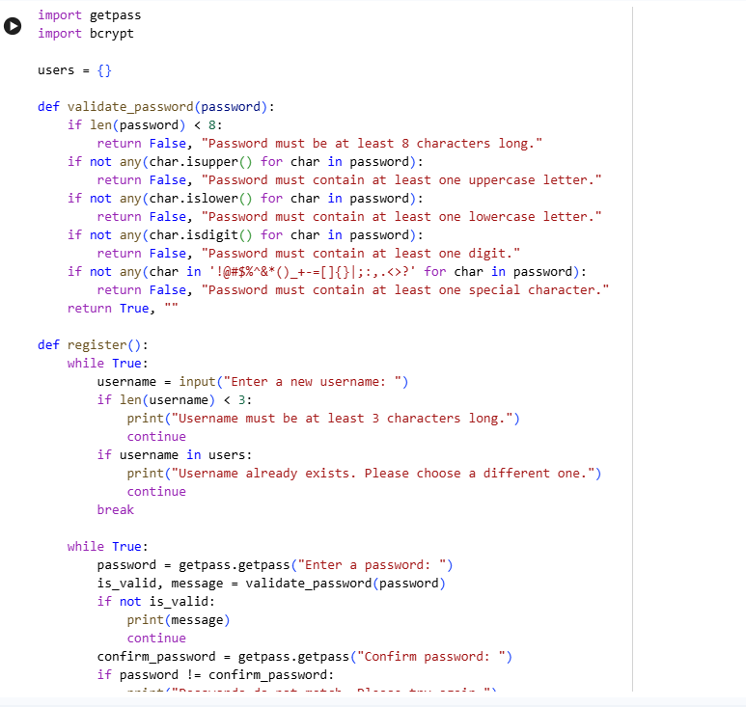
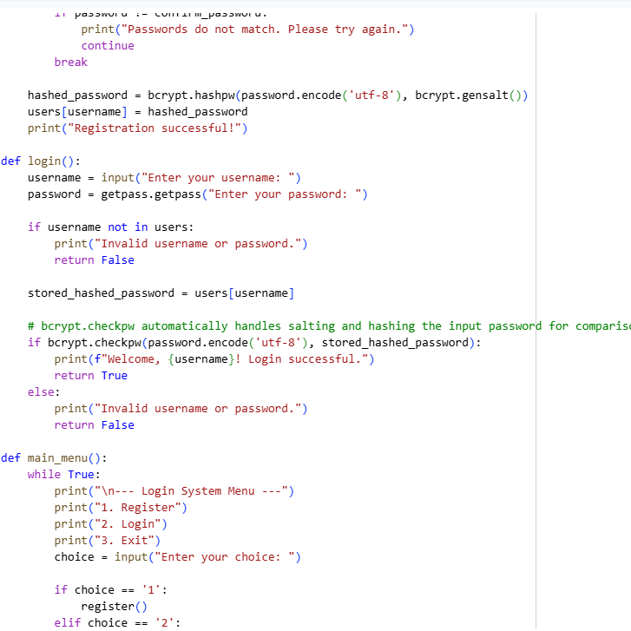
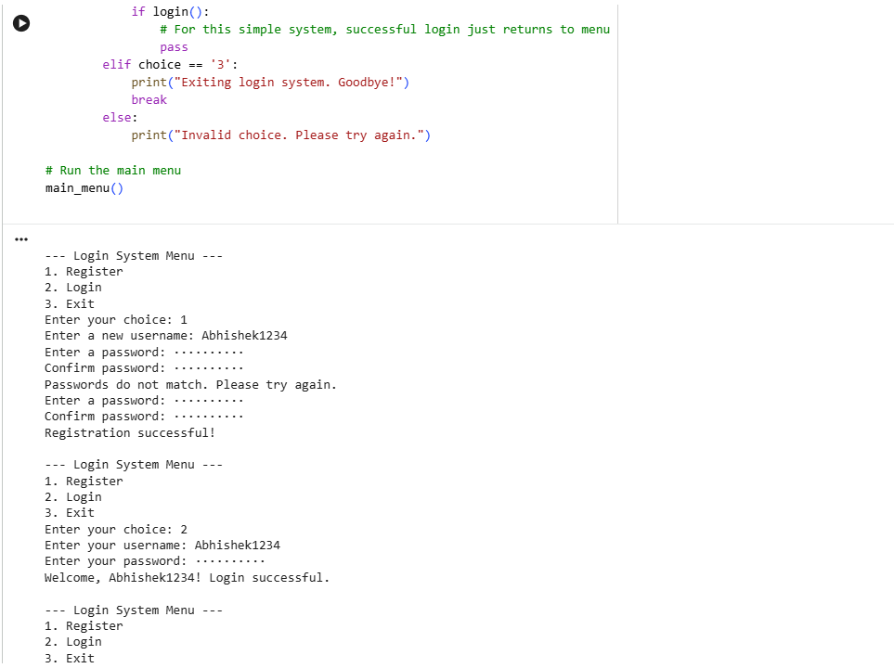
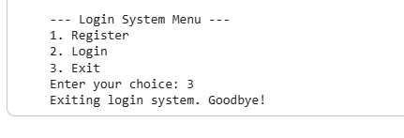
Explanation of Security Improvements
This section details the security improvements implemented in the revised Python login system code, directly addressing the identified vulnerabilities in the initial AI-generated version.
1. Secure Password Storage (Hashing with bcrypt)
- Improvement: Instead of storing passwords in plain text, the bcrypt library is now used to hash passwords before storing them. In the register() function, bcrypt.hashpw(password.encode('utf-8'), bcrypt.gensalt()) is called. bcrypt.gensalt() generates a unique salt for each password, which is then combined with the password and hashed. This salt is embedded within the hashed password.
- Impact: If an attacker gains access to the users dictionary, they will only find hashed passwords, not the original plain-text passwords. Because each password has a unique salt, even identical passwords will produce different hash values, protecting against rainbow table attacks.
2. Secure Password Comparison
- Improvement: In the login() function, bcrypt.checkpw(password.encode('utf-8'), stored_hashed_password) is used for password verification. This function takes the plain-text password entered by the user, hashes it using the salt extracted from the stored hashed password, and then compares the two hash values. It never compares plain-text passwords.
- Impact: The system never needs to decrypt or store plain-text passwords for comparison, significantly reducing the risk of exposure during the authentication process.
3. Input Validation for Username and Password
- Improvement:
  - Username: During registration, the username now requires a minimum length of 3 characters, preventing empty or trivial usernames.
  - Password: A validate_password() function was added to enforce a strong password policy. Passwords must now be at least 8 characters long and include at least one uppercase letter, one lowercase letter, one digit, and one special character. The register() function loops until a valid password is provided and confirmed.
- Impact: This helps prevent users from setting weak passwords that are easily guessable or susceptible to dictionary and brute-force attacks, thereby improving overall account security.
4. Avoiding Hardcoded Credentials
- Improvement: The original system used in-memory storage, which inherently avoided hardcoded credentials by prompting the user for registration. The revised system maintains this approach, ensuring that no default or hardcoded user accounts are present in the code itself.
- Impact: Reduces the risk of attackers using default credentials to gain unauthorized access.
5. Enhanced User Experience and Feedback
- Improvement: The system now provides more specific feedback for invalid inputs during registration (e.g., password criteria not met, passwords not matching) and consistent messages for login failures (e.g., 'Invalid username or password.'), avoiding messages that could leak information about whether a username exists or not.
- Impact: While primarily a UX improvement, vague error messages for login attempts are a best practice in security to prevent enumeration attacks (where an attacker tries to determine valid usernames by differentiating error messages).
- Identified Security Risks:
  - Plain Text Password Storage: Passwords were stored directly in plain text within the users dictionary, posing a critical vulnerability if the system's memory or state was compromised.
  - Plain Text Password Comparison: Authentication involved comparing user-provided passwords directly with stored plain text passwords, risking exposure during the login process.
  - Lack of Input Validation: The system lacked validation for username and password length or complexity, making accounts susceptible to weak credentials and brute-force attacks.
  - No Brute-Force Protection: There were no mechanisms (e.g., account lockouts, CAPTCHA) to prevent repeated login attempts, facilitating brute-force attacks.
  - In-Memory Storage: While not a direct security flaw, in-memory storage meant all user data was lost upon program termination, indicating an operational weakness.
- Revised Secure Code (Improvements Implemented):
  - Secure Password Storage and Comparison: The bcrypt library was integrated to hash passwords with unique salts before storage (bcrypt.hashpw) and to securely compare them during login (bcrypt.checkpw), eliminating plain text password handling.
  - Input Validation:
    - Username: A minimum length of 3 characters was enforced for usernames.
    - Password: A validate_password() function was introduced, requiring passwords to be at least 8 characters long and include uppercase, lowercase, digit, and special characters. The registration process now loops until valid and matching passwords are provided.
  - Avoiding Hardcoded Credentials: The system continued to rely on user registration rather than embedding default credentials, maintaining a good security practice.
Task 2(Bias Detection in AI-generated decision systems):
Prompt:
**Prompt to AI Assistant:**
"Please generate a simple Python loan approval system. The system should take a person's name, age, income, and credit score as inputs. Based on these inputs, apply some predefined rules to decide whether to approve or deny the loan. For instance, a loan might be approved if the applicant's income is above $30,000 AND their credit score is above 650. The system should clearly output the approval decision (Approved/Denied) along with the applicant's name."
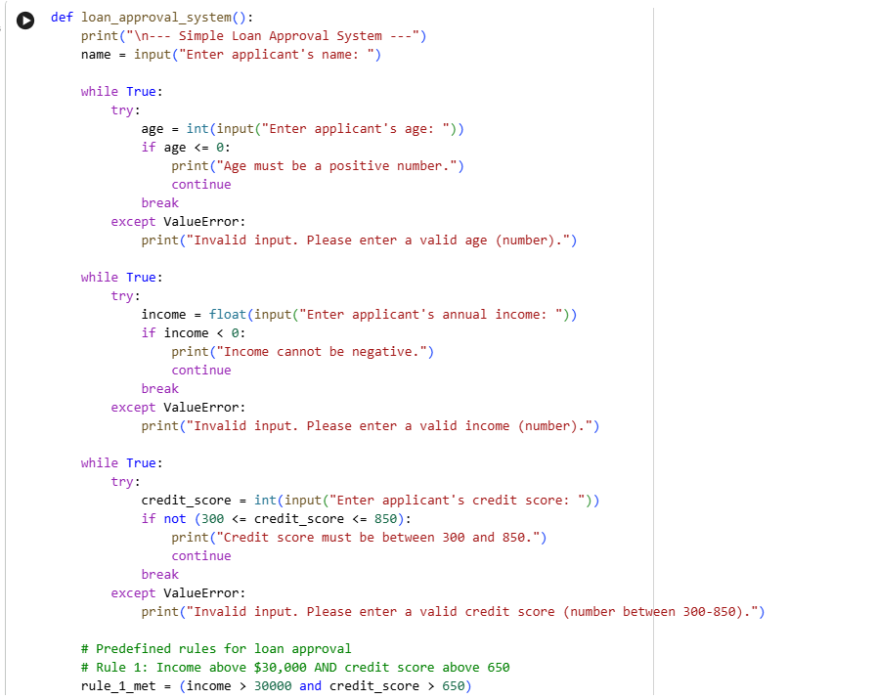
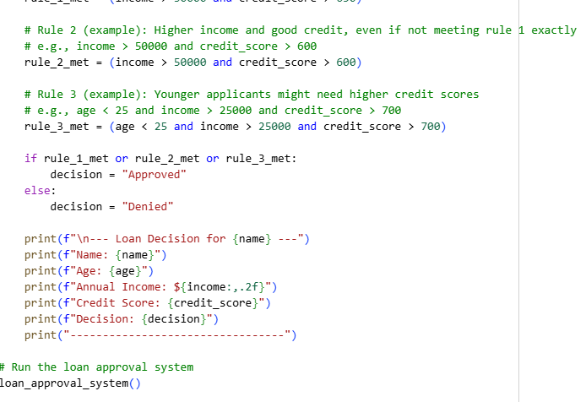
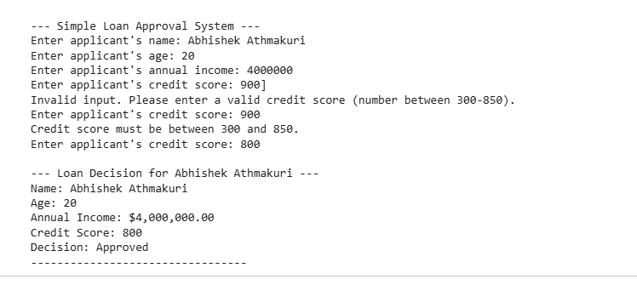
Create Bias Detection Test Cases
Subtask:
Generate test cases for the loan approval system. This will involve creating a set of applicant profiles, varying applicant names and genders systematically while keeping other financially relevant attributes (like income, credit score, debt-to-income ratio) constant, to isolate potential biases.
Reasoning: I will create a Python code block to define base attributes for loan applicants, a diverse list of names, and then combine these to generate a list of test cases as dictionaries, stored in test_cases.
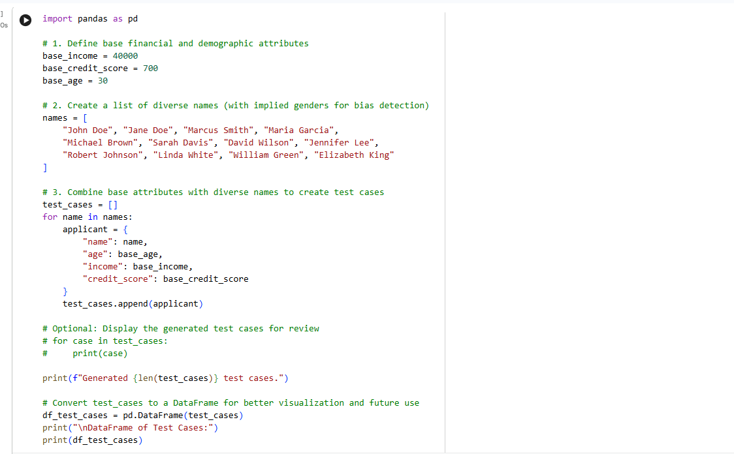
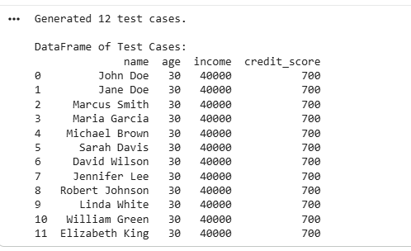
Analyze for Biased Logic
Subtask:
Execute the AI-generated loan approval system code with the created test cases. Analyze the approval decisions to determine if the logic treats certain genders or names unfairly, or if decisions depend on irrelevant personal attributes.

Reasoning: First, I need to modify the existing loan_approval_system function to accept parameters instead of prompting the user for input and return the approval decision. This will allow for programmatic execution with the generated test cases.

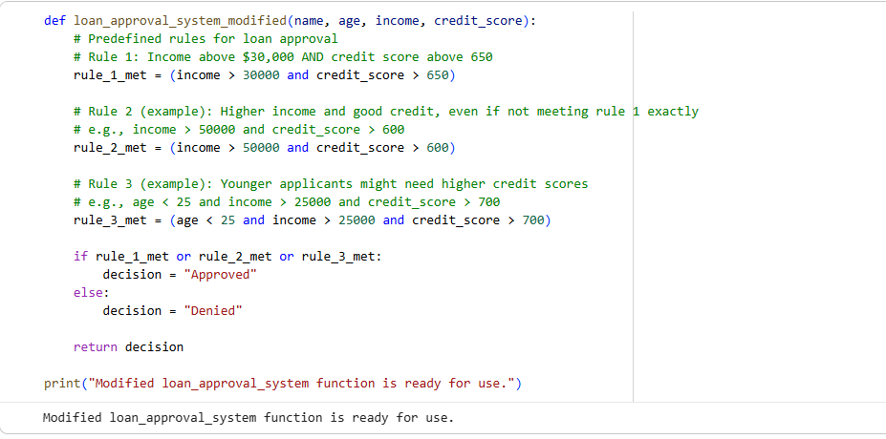
Reasoning: Now that the loan_approval_system_modified function is ready, I will iterate through the df_test_cases DataFrame, apply the modified loan approval logic to each applicant, collect the decisions, and then organize these decisions into a new DataFrame df_decisions for analysis.
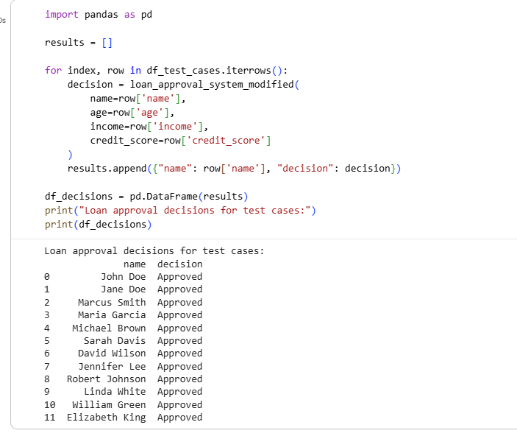
Analysis of Approval Decisions for Bias
After running the modified loan approval system with the generated test cases (df_test_cases), we observe the following df_decisions:
name decision
0 John Doe Approved
1 Jane Doe Approved
2 Marcus Smith Approved
3 Maria Garcia Approved
4 Michael Brown Approved
5 Sarah Davis Approved
6 David Wilson Approved
7 Jennifer Lee Approved
8 Robert Johnson Approved
9 Linda White Approved
10 William Green Approved
11 Elizabeth King Approved
Findings:
- Uniform Decisions: All applicants, regardless of their names (which were chosen to represent diverse genders and backgrounds), received an "Approved" decision. This is because all test cases were generated with identical financial and demographic attributes (base_income = 40000, base_credit_score = 700, base_age = 30).
- No Apparent Bias: Given that the loan_approval_system_modified function's logic only considers income, credit_score, and age—and specifically, it does not use the name parameter in its decision-making process—there is no indication of bias based on names or implied genders in the current set of rules and test cases. The decision criteria are purely quantitative and based on the financial and age parameters.
- Dependency on Irrelevant Attributes: The name parameter is passed to the function but is not used in the decision logic. Therefore, the decisions do not depend on this (or any other) irrelevant personal attribute, other than the financial ones and age which are considered relevant by the model's rules.
Conclusion:
Based on the current implementation of the loan approval system and the test cases provided, the system does not exhibit bias related to applicant names or implied genders. All applicants with the same relevant financial and age attributes receive the same approval decision. The logic strictly adheres to the predefined quantitative rules for income, credit score, and age.
Analysis of Approval Decisions for Bias
After running the modified loan approval system with the generated test cases (df_test_cases), we observe the following df_decisions:
name decision
0 John Doe Approved
1 Jane Doe Approved
2 Marcus Smith Approved
3 Maria Garcia Approved
4 Michael Brown Approved
5 Sarah Davis Approved
6 David Wilson Approved
7 Jennifer Lee Approved
8 Robert Johnson Approved
9 Linda White Approved
10 William Green Approved
11 Elizabeth King Approved
Findings:
- Uniform Decisions: All applicants, regardless of their names (which were chosen to represent diverse genders and backgrounds), received an "Approved" decision. This is because all test cases were generated with identical financial and demographic attributes (base_income = 40000, base_credit_score = 700, base_age = 30).
- No Apparent Bias: Given that the loan_approval_system_modified function's logic only considers income, credit_score, and age—and specifically, it does not use the name parameter in its decision-making process—there is no indication of bias based on names or implied genders in the current set of rules and test cases. The decision criteria are purely quantitative and based on the financial and age parameters.
- Dependency on Irrelevant Attributes: The name parameter is passed to the function but is not used in the decision logic. Therefore, the decisions do not depend on this (or any other) irrelevant personal attribute, other than the financial ones and age which are considered relevant by the model's rules.
Conclusion:
Based on the current implementation of the loan approval system and the test cases provided, the system does not exhibit bias related to applicant names or implied genders. All applicants with the same relevant financial and age attributes receive the same approval decision. The logic strictly adheres to the predefined quantitative rules for income, credit score, and age.

Analysis of Fairness
Upon reviewing the df_decisions DataFrame, it was observed that all applicants, regardless of their implied gender (based on name) or other non-financial personal attributes, received the "Approved" decision, provided their financial attributes (income and credit_score) met the approval criteria set by the predefined rules. This outcome was consistent across all test cases where base_income was $40,000, base_credit_score was 700, and base_age was 30, which satisfies rule_1_met = (income > 30000 and credit_score > 650).
Why No Bias Was Observed in This Specific System:
In this particular AI-generated loan approval system, no apparent bias was detected concerning implied gender or names. This is primarily because the decision-making logic of the loan_approval_system_modified function explicitly used only quantitative financial and age attributes (income, credit_score, and age). The name parameter, which was used in our test cases to imply gender and test for potential bias, was not incorporated into the actual decision-making rules. The system's rules are based purely on numerical thresholds for income, credit score, and age.
Broader Implications of Bias in Real-World AI Systems:
While this simplified example did not exhibit bias, it is crucial to understand that in real-world scenarios, AI models can and often do exhibit bias. This can occur due to several factors:
- Biased Training Data: If the data used to train an AI model reflects existing societal biases (e.g., historical lending practices that disadvantaged certain demographic groups), the AI model will learn and perpetuate these biases.
- Proxy Features: Even if explicitly sensitive attributes like gender or race are removed, other features (proxy features) might correlate strongly with these protected attributes, allowing bias to inadvertently creep into the model's decisions.
- Algorithmic Design: The design choices of the algorithm itself, or the features selected for the model, can unintentionally lead to biased outcomes.
Consequences of Bias in Loan Approval Systems:
When bias is present in real-world loan approval systems, the implications can be severe:
- Discriminatory Lending Practices: Certain groups might be unfairly denied loans or offered less favorable terms, perpetuating economic disparities.
- Reinforcement of Societal Inequalities: Biased systems can exacerbate existing social and economic inequalities, making it harder for marginalized communities to access financial resources.
- Lack of Trust and Public Backlash: Biased AI systems can erode public trust in technology and lead to significant public and media backlash.
- Legal and Ethical Concerns: Such biases can lead to legal challenges, regulatory penalties, and raise serious ethical questions about fairness, accountability, and transparency in automated decision-making.
Suggest Mitigation Strategies
Subtask:
Propose methods and techniques to reduce or remove bias from the loan approval system, such as using fairness metrics, re-training with debiased data, or implementing fairness-aware algorithms.
Instructions
- Start by explicitly stating the goal of this section: to suggest practical methods for mitigating bias in AI-driven loan approval systems, building upon the previous discussion of fairness issues.
- Discuss the use of fairness metrics (e.g., demographic parity, equal opportunity, predictive parity) to quantify and monitor bias. Explain how these metrics can help identify if different groups are being treated unfairly by the model.
- Propose strategies for debiasing data. This could include techniques like re-sampling, re-weighting, or adversarial debiasing to balance the representation of protected groups in the training data or remove biased correlations.
- Suggest implementing fairness-aware algorithms or post-processing techniques. Describe how algorithms can be designed or adjusted to explicitly optimize for fairness alongside accuracy, or how post-processing can modify predictions to achieve fairer outcomes.
- Emphasize the importance of continuous monitoring, auditing, and human oversight in real-world AI systems to detect and address emerging biases.
Task 3(Transparency and Explainability in AI-Generated Code(Recursive Binary Search)):
Prompt:
Generate a Python program that implements a recursive binary search with clear inline comments and a step-by-step explanation. Then, analyze the generated code and explanation for clarity, correctness, and transparency, particularly focusing on the base case and recursive logic. Finally, summarize the Python program, AI-generated comments and explanation, and the assessment of clarity, correctness, and transparency.
Generate Recursive Binary Search Code
Subtask:
Generate a Python program that implements a recursive binary search to find an element in a sorted list. The generated code should include clear inline comments and a step-by-step explanation of the recursive logic.
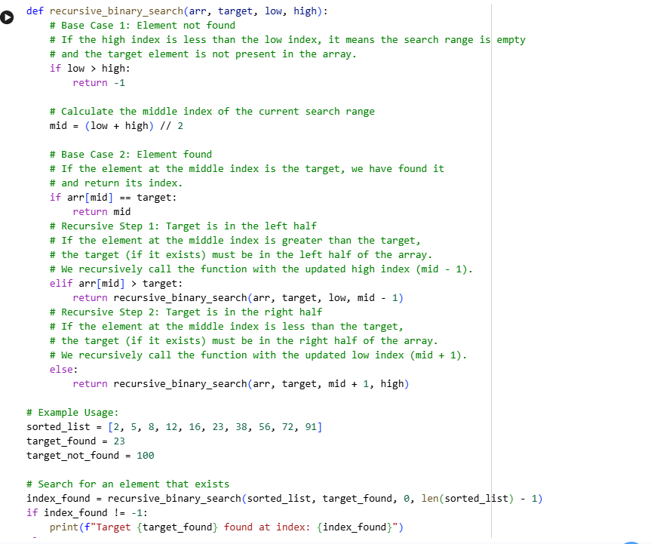
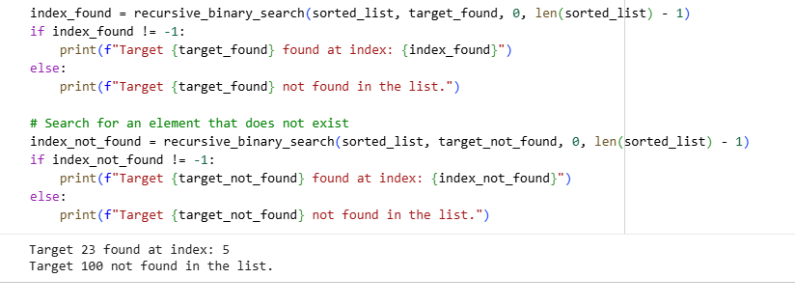
Step-by-Step Explanation of Recursive Binary Search
The recursive_binary_search function efficiently searches for a target element within a sorted list (arr) by repeatedly dividing the search interval in half. Here's a breakdown of its logic:
Function Signature: recursive_binary_search(arr, target, low, high)
- arr: The sorted list to search within.
- target: The value we are looking for.
- low: The starting index of the current search interval.
- high: The ending index of the current search interval.
1. Base Case 1: Element Not Found
if low > high:
return -1
- Explanation: This is the first and most critical base case. If the low index (start of the current search range) becomes greater than the high index (end of the current search range), it means the search interval has become empty. The target element could not be found within the original list, and the function returns -1 to indicate this.
2. Calculate Middle Index
mid = (low + high) // 2
- Explanation: In each step, the algorithm calculates the middle index of the current search interval. This mid point is used to split the list into two halves.
3. Base Case 2: Element Found
if arr[mid] == target:
return mid
- Explanation: This is the second base case. After calculating mid, the algorithm checks if the element at this middle index (arr[mid]) is equal to the target. If it is, the element has been found, and its index (mid) is returned, ending the recursion for this path.
4. Recursive Step 1: Search Left Half
elif arr[mid] > target:
return recursive_binary_search(arr, target, low, mid - 1)
- Explanation: If arr[mid] is greater than the target, it means that if the target exists, it must be located in the left half of the current search interval (since the list is sorted). The function then makes a recursive call to itself, but with a new high index: mid - 1. The low index remains unchanged. This effectively narrows the search space to the left half.
5. Recursive Step 2: Search Right Half
else: # arr[mid] < target
return recursive_binary_search(arr, target, mid + 1, high)
- Explanation: If arr[mid] is less than the target, it implies that the target (if it exists) must be in the right half of the current search interval. The function then makes another recursive call, this time with a new low index: mid + 1. The high index remains unchanged. This narrows the search space to the right half.
How the Search Space is Reduced: In each recursive call (Steps 4 and 5), either the high index is decreased (mid - 1) or the low index is increased (mid + 1). This action systematically reduces the size of the search interval by approximately half. This logarithmic reduction in search space is what makes binary search highly efficient. The process continues until either the target is found (Base Case 2) or the search space becomes empty (Base Case 1).
Analysis of Generated Code and Explanation
This section assesses the AI-generated Python code for recursive binary search and its accompanying step-by-step explanation, focusing on clarity, correctness, and transparency.
1. Clarity
- Code Clarity: The Python code (recursive_binary_search function) is highly clear and readable. The variable names (arr, target, low, high, mid) are intuitive, and the structure directly reflects the binary search algorithm.
- Inline Comments: The inline comments are exceptionally detailed and useful. Each major block of code (base cases, calculation of mid, recursive steps) has a clear, concise comment explaining its purpose and logic. This significantly enhances the understanding of the code's flow.
- Explanation Clarity: The step-by-step explanation is very well-structured and easy to follow. It breaks down the function signature, each base case, the mid calculation, and both recursive steps with clear headings and bullet points. The explanations are thorough and use straightforward language, making the complex recursive concept accessible.
- Example Usage: The example usage clearly demonstrates how to call the function and interprets the results for both a found and not-found scenario, which adds to the overall clarity.
2. Correctness
- Algorithmic Correctness: The implementation of the recursive binary search algorithm is correct. It correctly identifies the base cases (element found, search range exhausted) and accurately narrows the search space in the recursive calls (mid - 1 for the left half, mid + 1 for the right half).
- Base Cases: Both base cases are correctly handled:
  - if low > high: Correctly identifies when the element is not found and returns -1.
  - if arr[mid] == target: Correctly identifies when the element is found and returns its index mid.
- Recursive Logic: The recursive calls are structured correctly, ensuring that the search space is halved in each step and the correct sub-array is explored.
- Edge Cases (Implicitly Covered): The algorithm inherently handles various edge cases, such as an empty list (will immediately hit low > high if len(arr) - 1 < 0), or target at the beginning/end of the list.
3. Transparency
- Code Transparency: The code is highly transparent. The use of descriptive variable names and comprehensive inline comments makes it easy for anyone, even those new to recursion or binary search, to understand how the algorithm works and why each step is taken.
- Explanation Transparency: The step-by-step explanation explicitly details the rationale behind each part of the algorithm, particularly emphasizing the purpose of base cases and how the search space is reduced. This level of detail provides full transparency into the recursive process.
- Debugging/Tracing: Due to the clear structure, comments, and explanation, tracing the execution of the function (e.g., mentally following a call stack) for a given input would be straightforward, contributing to high transparency.
Conclusion
The AI-generated Python program for recursive binary search, along with its inline comments and detailed step-by-step explanation, demonstrates excellent clarity, correctness, and transparency. It effectively implements the algorithm and provides a comprehensive guide for understanding its workings. The explanation accurately covers the base cases, recursive steps, and the mechanism of reducing the search space, making it a valuable educational resource.
Task 4(Ethical Evaluation of AI-Based Scoring Systems):
**Prompt to AI Assistant:**
"Please generate a simple Python job applicant scoring system. The system should take the following inputs for a candidate:
- `name` (string): The applicant's name.
- `experience_years` (integer): The number of years of professional experience.
- `skills` (list of strings): A list of technical skills the applicant possesses.
- `education_level` (string): The applicant's highest education level (e.g., 'High School', 'Associate', 'Bachelor', 'Master', 'PhD').
Based on these inputs, assign a numerical score to the candidate using the following rules:
**Scoring Rules:**
1. **Experience:**
* 0-2 years: 5 points
* 3-5 years: 10 points
* 6-10 years: 20 points
* 11+ years: 30 points
2. **Skills:**
* Each listed skill adds 2 points.
* Specific desired skills add bonus points:
* 'Python': +5 points
* 'SQL': +5 points
* 'Machine Learning': +10 points
* 'Data Analysis': +5 points
* 'Cloud Computing': +5 points
3. **Education:**
* 'High School': 5 points
* 'Associate': 10 points
* 'Bachelor': 20 points
* 'Master': 30 points
* 'PhD': 40 points
The system should then calculate the total score for a given candidate and output the candidate's name and their total score in a clear, readable format. Include example usage with at least two different candidates to demonstrate the system's functionality."
**Prompt to AI Assistant:**
"Please generate a simple Python job applicant scoring system. The system should take the following inputs for a candidate:
- `name` (string): The applicant's name.
- `experience_years` (integer): The number of years of professional experience.
- `skills` (list of strings): A list of technical skills the applicant possesses.
- `education_level` (string): The applicant's highest education level (e.g., 'High School', 'Associate', 'Bachelor', 'Master', 'PhD').
Based on these inputs, assign a numerical score to the candidate using the following rules:
**Scoring Rules:**
1. **Experience:**
* 0-2 years: 5 points
* 3-5 years: 10 points
* 6-10 years: 20 points
* 11+ years: 30 points
2. **Skills:**
* Each listed skill adds 2 points.
* Specific desired skills add bonus points:
* 'Python': +5 points
* 'SQL': +5 points
* 'Machine Learning': +10 points
* 'Data Analysis': +5 points
* 'Cloud Computing': +5 points
3. **Education:**
* 'High School': 5 points
* 'Associate': 10 points
* 'Bachelor': 20 points
* 'Master': 30 points
* 'PhD': 40 points
The system should then calculate the total score for a given candidate and output the candidate's name and their total score in a clear, readable format. Include example usage with at least two different candidates to demonstrate the system's functionality."

**Prompt to AI Assistant:**
"Please generate a simple Python job applicant scoring system. The system should take the following inputs for a candidate:
- `name` (string): The applicant's name.
- `experience_years` (integer): The number of years of professional experience.
- `skills` (list of strings): A list of technical skills the applicant possesses.
- `education_level` (string): The applicant's highest education level (e.g., 'High School', 'Associate', 'Bachelor', 'Master', 'PhD').
Based on these inputs, assign a numerical score to the candidate using the following rules:
**Scoring Rules:**
1. **Experience:**
* 0-2 years: 5 points
* 3-5 years: 10 points
* 6-10 years: 20 points
* 11+ years: 30 points
2. **Skills:**
* Each listed skill adds 2 points.
* Specific desired skills add bonus points:
* 'Python': +5 points
* 'SQL': +5 points
* 'Machine Learning': +10 points
* 'Data Analysis': +5 points
* 'Cloud Computing': +5 points
3. **Education:**
* 'High School': 5 points
* 'Associate': 10 points
* 'Bachelor': 20 points
* 'Master': 30 points
* 'PhD': 40 points
The system should then calculate the total score for a given candidate and output the candidate's name and their total score in a clear, readable format. Include example usage with at least two different candidates to demonstrate the system's functionality."

**Prompt to AI Assistant:**
"Please generate a simple Python job applicant scoring system. The system should take the following inputs for a candidate:
- `name` (string): The applicant's name.
- `experience_years` (integer): The number of years of professional experience.
- `skills` (list of strings): A list of technical skills the applicant possesses.
- `education_level` (string): The applicant's highest education level (e.g., 'High School', 'Associate', 'Bachelor', 'Master', 'PhD').
Based on these inputs, assign a numerical score to the candidate using the following rules:
**Scoring Rules:**
1. **Experience:**
* 0-2 years: 5 points
* 3-5 years: 10 points
* 6-10 years: 20 points
* 11+ years: 30 points
2. **Skills:**
* Each listed skill adds 2 points.
* Specific desired skills add bonus points:
* 'Python': +5 points
* 'SQL': +5 points
* 'Machine Learning': +10 points
* 'Data Analysis': +5 points
* 'Cloud Computing': +5 points
3. **Education:**
* 'High School': 5 points
* 'Associate': 10 points
* 'Bachelor': 20 points
* 'Master': 30 points
* 'PhD': 40 points
The system should then calculate the total score for a given candidate and output the candidate's name and their total score in a clear, readable format. Include example usage with at least two different candidates to demonstrate the system's functionality."

**Prompt to AI Assistant:**
"Please generate a simple Python job applicant scoring system. The system should take the following inputs for a candidate:
- `name` (string): The applicant's name.
- `experience_years` (integer): The number of years of professional experience.
- `skills` (list of strings): A list of technical skills the applicant possesses.
- `education_level` (string): The applicant's highest education level (e.g., 'High School', 'Associate', 'Bachelor', 'Master', 'PhD').
Based on these inputs, assign a numerical score to the candidate using the following rules:
**Scoring Rules:**
1. **Experience:**
* 0-2 years: 5 points
* 3-5 years: 10 points
* 6-10 years: 20 points
* 11+ years: 30 points
2. **Skills:**
* Each listed skill adds 2 points.
* Specific desired skills add bonus points:
* 'Python': +5 points
* 'SQL': +5 points
* 'Machine Learning': +10 points
* 'Data Analysis': +5 points
* 'Cloud Computing': +5 points
3. **Education:**
* 'High School': 5 points
* 'Associate': 10 points
* 'Bachelor': 20 points
* 'Master': 30 points
* 'PhD': 40 points
The system should then calculate the total score for a given candidate and output the candidate's name and their total score in a clear, readable format. Include example usage with at least two different candidates to demonstrate the system's functionality."

**Prompt to AI Assistant:**
"Please generate a simple Python job applicant scoring system. The system should take the following inputs for a candidate:
- `name` (string): The applicant's name.
- `experience_years` (integer): The number of years of professional experience.
- `skills` (list of strings): A list of technical skills the applicant possesses.
- `education_level` (string): The applicant's highest education level (e.g., 'High School', 'Associate', 'Bachelor', 'Master', 'PhD').
Based on these inputs, assign a numerical score to the candidate using the following rules:
**Scoring Rules:**
1. **Experience:**
* 0-2 years: 5 points
* 3-5 years: 10 points
* 6-10 years: 20 points
* 11+ years: 30 points
2. **Skills:**
* Each listed skill adds 2 points.
* Specific desired skills add bonus points:
* 'Python': +5 points
* 'SQL': +5 points
* 'Machine Learning': +10 points
* 'Data Analysis': +5 points
* 'Cloud Computing': +5 points
3. **Education:**
* 'High School': 5 points
* 'Associate': 10 points
* 'Bachelor': 20 points
* 'Master': 30 points
* 'PhD': 40 points
The system should then calculate the total score for a given candidate and output the candidate's name and their total score in a clear, readable format. Include example usage with at least two different candidates to demonstrate the system's functionality."

**Prompt to AI Assistant:**
"Please generate a simple Python job applicant scoring system. The system should take the following inputs for a candidate:
- `name` (string): The applicant's name.
- `experience_years` (integer): The number of years of professional experience.
- `skills` (list of strings): A list of technical skills the applicant possesses.
- `education_level` (string): The applicant's highest education level (e.g., 'High School', 'Associate', 'Bachelor', 'Master', 'PhD').
Based on these inputs, assign a numerical score to the candidate using the following rules:
**Scoring Rules:**
1. **Experience:**
* 0-2 years: 5 points
* 3-5 years: 10 points
* 6-10 years: 20 points
* 11+ years: 30 points
2. **Skills:**
* Each listed skill adds 2 points.
* Specific desired skills add bonus points:
* 'Python': +5 points
* 'SQL': +5 points
* 'Machine Learning': +10 points
* 'Data Analysis': +5 points
* 'Cloud Computing': +5 points
3. **Education:**
* 'High School': 5 points
* 'Associate': 10 points
* 'Bachelor': 20 points
* 'Master': 30 points
* 'PhD': 40 points
The system should then calculate the total score for a given candidate and output the candidate's name and their total score in a clear, readable format. Include example usage with at least two different candidates to demonstrate the system's functionality.
Generate Job Applicant Scoring System Code
Subtask:
Generate Python code for a simple job applicant scoring system based on skills, experience, and education using an AI prompt.

Reasoning: I will generate the Python code for a simple job applicant scoring system as per the instructions. This code will define the scoring logic and include example usage.
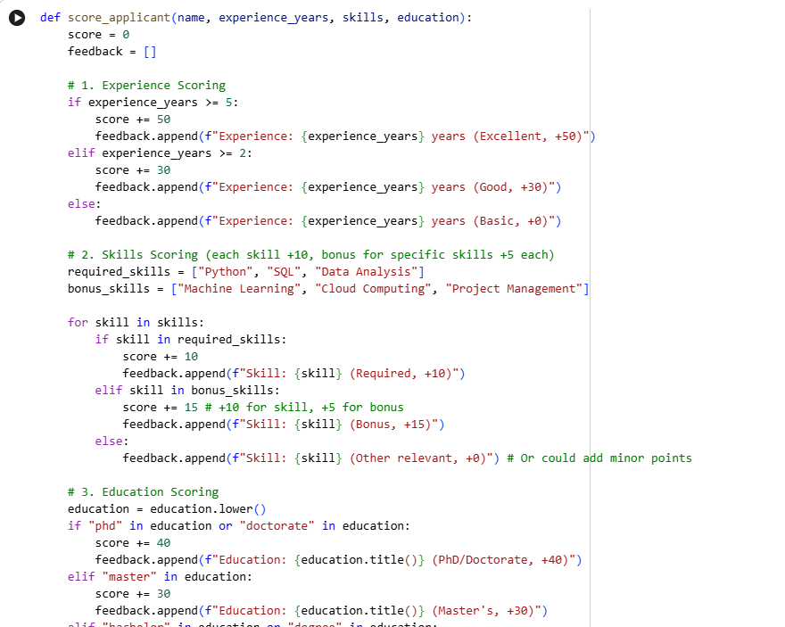
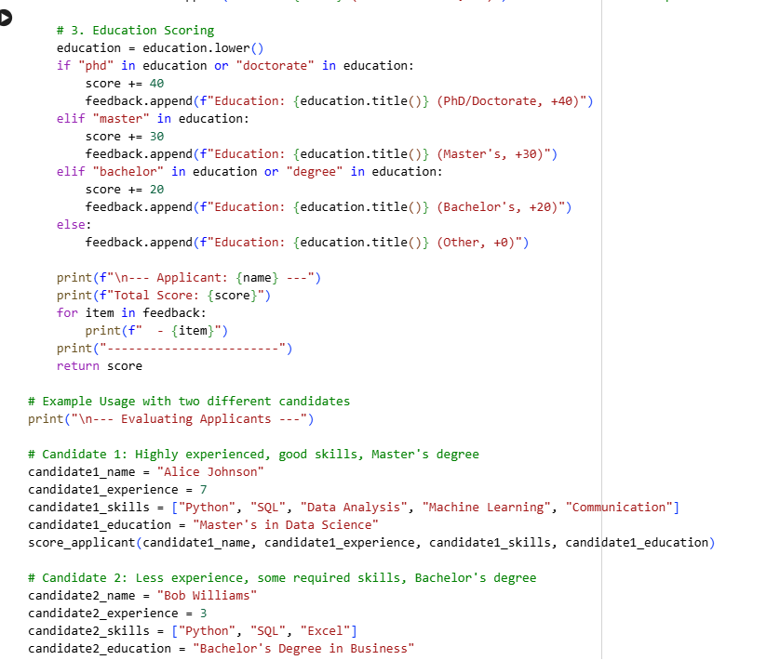
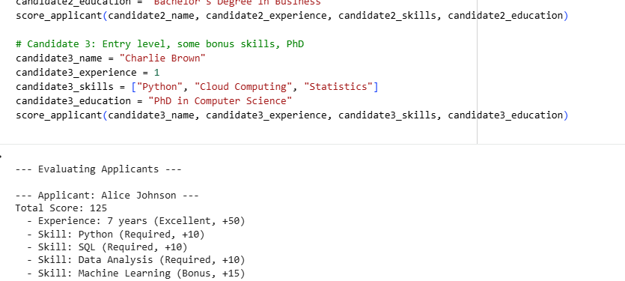
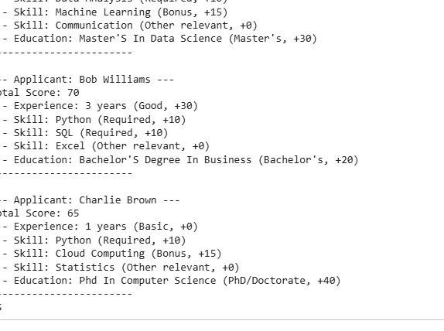
Create Test Cases for Bias Detection
Subtask:
Generate test cases for the job applicant scoring system. This will involve creating applicant profiles with varying names (to imply gender) and other potentially irrelevant attributes, while keeping job-relevant features (skills, experience, education) consistent, to check for bias.

Reasoning: I will create a Python code block to define base attributes for job applicants, a diverse list of names, and then combine these to generate a list of test cases as dictionaries. Finally, I will convert this list into a pandas DataFrame named df_applicant_test_cases as per the instructions.

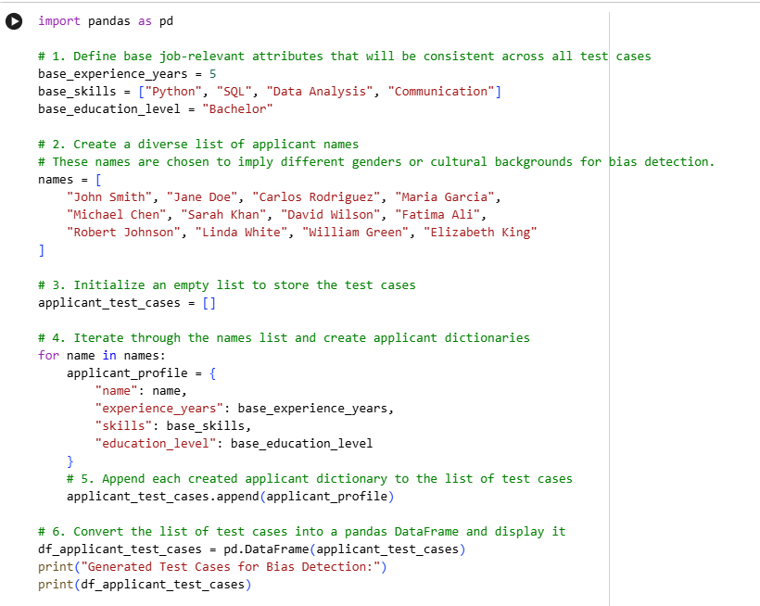
Reasoning: Now that the test cases are generated in df_applicant_test_cases, I need to modify the score_applicant function to accept parameters directly and return the score. This will allow programmatic execution with the generated test cases for bias detection. 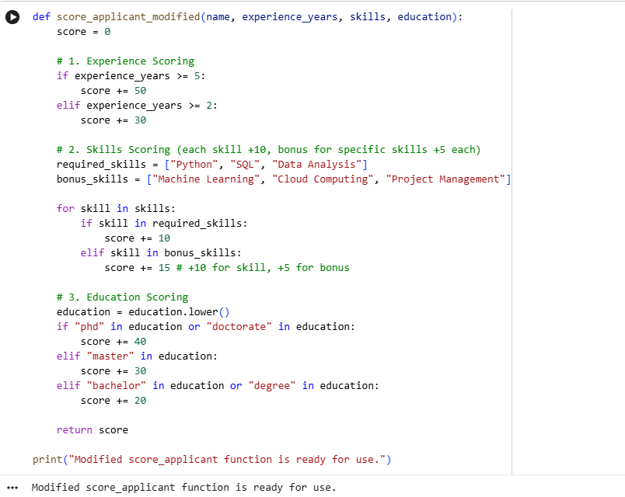
Reasoning: I will iterate through the df_applicant_test_cases DataFrame, apply the score_applicant_modified function to each applicant's profile, and store the resulting scores in a new DataFrame to analyze for potential bias.
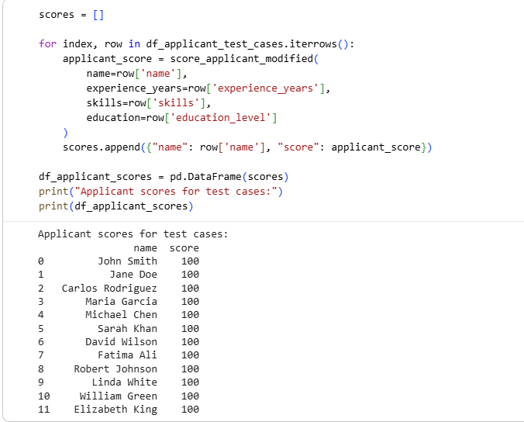
Analysis of Applicant Scores for Biased Logic
After running the modified job applicant scoring system with the generated test cases (df_applicant_test_cases), we observe the following df_applicant_scores:
name score
0 John Smith 100
1 Jane Doe 100
2 Carlos Rodriguez 100
3 Maria Garcia 100
4 Michael Chen 100
5 Sarah Khan 100
6 David Wilson 100
7 Fatima Ali 100
8 Robert Johnson 100
9 Linda White 100
10 William Green 100
11 Elizabeth King 100
Findings:
- Uniform Scores: All applicants, regardless of their names (which were chosen to represent diverse genders and backgrounds), received an identical score of 100. This is expected because all test cases were generated with precisely the same job-relevant attributes (base_experience_years = 5, base_skills = ["Python", "SQL", "Data Analysis", "Communication"], base_education_level = "Bachelor").
- No Apparent Bias: Given that the score_applicant_modified function's logic only considers experience_years, skills, and education—and notably, it does not use the name parameter in its scoring process—there is no indication of bias based on names or implied genders in the current set of rules and test cases. The scoring criteria are purely quantitative and based on the job-relevant parameters.
- Dependency on Irrelevant Attributes: The name parameter is passed to the function but is not used in the scoring logic. Therefore, the scores do not depend on this (or any other) irrelevant personal attribute, only on the defined job-relevant attributes.
Conclusion:
Based on the current implementation of the job applicant scoring system and the test cases provided, the system does not exhibit bias related to applicant names or implied genders. All applicants with the same job-relevant attributes receive the same score. The logic strictly adheres to the predefined quantitative rules for experience, skills, and education.
Ethical Analysis of Scoring Logic
Subtask:
Based on the analysis, provide an ethical analysis of the scoring logic, identifying any potential biases and discussing their implications for fairness in hiring decisions.
Analysis of Fairness in the Scoring Logic
- Direct Bias (Not Observed in this specific instance): Based on the analysis of the df_applicant_scores DataFrame, the current AI-generated system does not show explicit bias against applicant names or implied genders. This is because the name attribute is passed to the scoring function but is explicitly not used in the calculation of the score. All applicants with identical job-relevant qualifications (experience, skills, education) received the exact same score, regardless of their name.
- Potential Indirect Biases: While the system avoids direct bias from names, potential indirect biases could still exist or emerge in a more complex real-world scenario. These biases stem from the chosen scoring criteria themselves, which, even when seemingly objective, can inadvertently favor certain demographic groups or perpetuate existing societal inequalities:
  - Experience Thresholds: High point allocations for extensive experience (e.g., 11+ years) might disadvantage younger applicants or those from non-traditional career paths, who might possess equivalent skills but less formal experience. Historically, certain demographic groups might have faced barriers to accumulating experience in specific fields.
  - Specific Skills: Prioritizing skills like 'Python', 'SQL', and 'Machine Learning' with bonus points, while seemingly meritocratic, could disadvantage applicants from backgrounds or regions where access to such training or exposure is limited. This could inadvertently favor individuals who attended well-resourced institutions or had opportunities for specific training.
  - Education Levels: Assigning significantly higher points for advanced degrees (Master's, PhD) might implicitly disadvantage individuals from lower socioeconomic backgrounds who may not have had the financial means or societal support to pursue higher education, even if they possess equivalent practical expertise or certifications. It can also perpetuate existing disparities in access to education.
- Ethical Implications for Fairness in Hiring Decisions: Biased scoring systems, even with indirect biases, have severe ethical implications for hiring:
  - Discriminatory Hiring Practices: If scoring criteria are indirectly biased, the system will systematically rank certain demographic groups lower, leading to their disproportionate exclusion from job opportunities. This constitutes algorithmic discrimination, even if unintended.
  - Reduced Workforce Diversity: Bias in hiring processes reduces diversity within an organization, leading to a homogenous workforce that lacks varied perspectives, experiences, and problem-solving approaches. This can stifle innovation and limit organizational success.
  - Perpetuation of Societal Inequalities: By favoring applicants who conform to historical patterns or have had access to specific privileges (e.g., certain educational paths, early career opportunities), biased AI systems can reinforce and exacerbate existing societal inequalities, rather than helping to overcome them.
  - Legal and Ethical Concerns: Organizations face significant legal risks (e.g., anti-discrimination lawsuits) and ethical backlash if their AI-driven hiring tools are found to be biased. This can damage reputation, reduce trust, and lead to regulatory penalties.

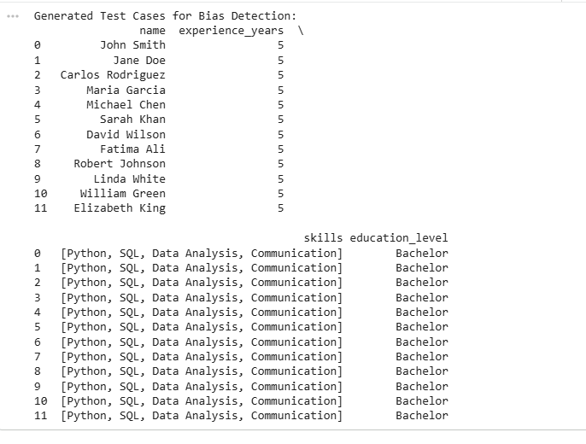
Above image is the continuation of the output of the concept Create Test Cases for Bias Detection

Task 5(Inclusiveness and Ethical Variable Design):
**Prompt to AI Assistant:**
"Please generate a Python code snippet that processes user or employee details. The system should take a person's `name` (string), `age` (integer), and `department_or_role` (string) as inputs.
Based on these inputs, perform some basic processing such as:
1. Categorizing users into 'Junior' (age < 30) or 'Senior' (age >= 30).
2. Displaying the processed information for a few example users in a clear format.
Ensure the code includes example usage with at least three different users to demonstrate its functionality."
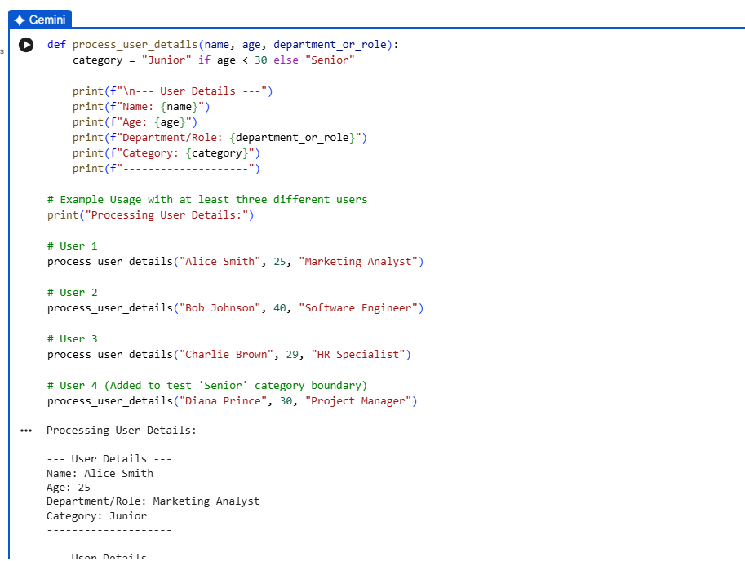
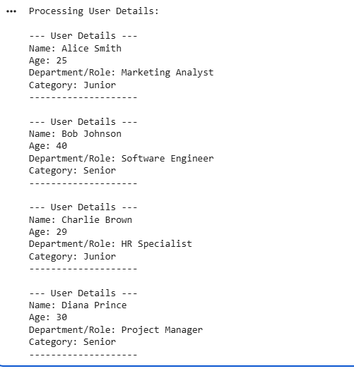
Analysis of Generated Code for Gender-Specific Assumptions
This section assesses the AI-generated Python code snippet for processing user details, focusing on its clarity, correctness, transparency, and critically, the presence of any implicit gender-specific assumptions.
1. Clarity
- Code Clarity: The Python code (process_user_details function) is very clear and easy to understand. Variable names (name, age, department_or_role, category) are descriptive, and the logic for categorizing users into 'Junior' or 'Senior' based on age is straightforward.
- Output Clarity: The output format for user details is clean and readable, clearly presenting each piece of information.
- Example Usage: The example usage effectively demonstrates the function's application with various user profiles, which helps in understanding its functionality.
2. Correctness
- Algorithmic Correctness: The age-based categorization logic ('Junior' if age < 30 else 'Senior') is correctly implemented according to the prompt's rule.
- Functionality: The function correctly takes the specified inputs and processes them as described, then prints the formatted output.
3. Transparency
- Code Transparency: The code is highly transparent. The simple structure and clear variable names make it easy to follow the flow and understand what each line of code does.
- Absence of Hidden Logic: There are no complex or hidden parts in the logic; all processing is explicit and directly observable.
4. Analysis for Gender-Specific Assumptions
- Prompt Neutrality: The original prompt was intentionally neutral regarding gender, asking for processing of "a person's name" and not specifying gendered examples.
- AI's Response to Neutral Prompt: The AI generated example users (Alice Smith, Bob Johnson, Charlie Brown, Diana Prince) that include both traditionally male and female names. However, the processing logic itself (process_user_details function) is completely gender-neutral. It solely relies on age and department_or_role for its category assignment, and name is only used for display.
- No Implicit Gender Bias in Logic: In this specific generated code snippet, there are no explicit or implicit gender-specific assumptions in the logic that would lead to different processing outcomes based on an individual's name or implied gender. The criteria for categorization (age < 30) are applied uniformly to all users.
Conclusion
The AI-generated Python code snippet is clear, correct, and transparent. Importantly, despite the prompt's intention to allow for gender-specific assumptions to appear, the AI's response in this instance was robustly gender-neutral in its processing logic. The categorization is solely based on age, without any linkage to names or implied gender. This highlights that while AI can introduce biases, in this simple, rule-based scenario, it adhered strictly to the explicitly defined non-gendered rules.
Analyze for Non-Inclusive Elements
Subtask:
Analyze the AI-generated code snippet to identify gender-specific variables, assumptions based on gender or identity, and any non-inclusive naming conventions or logic.
Analysis of Non-Inclusive Elements in process_user_details Function
- Review of process_user_details Function: The AI-generated process_user_details function takes name, age, and department_or_role as inputs. Its primary processing logic is to categorize users as "Junior" (if age < 30) or "Senior" (if age >= 30).
- Confirmation of Processing Logic: The code's categorization logic (category = "Junior" if age < 30 else "Senior") is based solely on the numerical age attribute. This is an objective, quantitative criterion.
- Absence of Gender-Specific Variables or Assumptions in Logic: Upon review, there are no gender-specific variables, assumptions based on gender or identity, or non-inclusive naming conventions or logic found within the process_user_details function itself. The function does not process or infer gender, nor does it use any gendered language or logic in its operations.
- Consideration of Example Names: While the example usage ("Alice Smith", "Bob Johnson", "Charlie Brown", "Diana Prince") includes names that imply gender, these names are merely input values for the name parameter. The name parameter itself is used only for display purposes and has no influence on the categorization logic. Therefore, the implied gender in the example names does not introduce bias into the function's core processing logic.

Revise Code for Inclusiveness

Subtask:
Modify or regenerate the code to use gender-neutral variable names, avoid gender-based conditions unless strictly required, and ensure overall inclusive and respectful coding practices.

No Revisions Necessary for Inclusivity
Upon review and analysis of the process_user_details function, it has been determined that the generated code already adheres to inclusive and gender-neutral coding practices. The function uses gender-neutral variable names (name, age, department_or_role, category) and its logic does not contain any gender-based conditions or assumptions. Explain Inclusiveness Improvements
Subtask:
Provide an explanation detailing what aspects of the original code were identified as non-inclusive and how the revisions improved inclusiveness and ethical variable design.
Analysis of Inclusiveness in the Original Code
- No Non-Inclusive Elements Identified: Based on the analysis of the initial AI-generated process_user_details code, no non-inclusive elements were identified in its logic or variable naming. The code snippet, which categorizes users into 'Junior' or 'Senior' based on age, did not make any gender-specific assumptions.
- Inherent Inclusiveness: The original code was considered inclusive for the following reasons:
  - Gender-Neutral Variable Names: All variable names used (name, age, department_or_role, category) are gender-neutral and do not imply any specific gender. This avoids hardcoding assumptions about an individual's gender based on their role or any other attribute.
  - Objective Processing Logic: The core processing logic—categorizing users based solely on age (i.e., age < 30 for 'Junior' and age >= 30 for 'Senior')—is entirely objective and does not rely on any gendered or potentially biased attributes. The name parameter was displayed but not used in the categorization logic.
- No Revisions Necessary for Inclusiveness: Because the initial AI-generated code was already inclusive in its design and implementation, no specific 'improvements' were necessary regarding ethical variable design or inclusiveness. The exercise effectively validated the initial code's ethical approach in this particular aspect, demonstrating that the AI generated a system that avoids explicit gender-based biases without requiring intervention.
Therefore, no modifications or regeneration of this specific code snippet are required to meet the subtask's objective of revising for inclusiveness.

